- To connect to park.mdf from visual studio you must open server explorer go to tools and select Connect to Server.
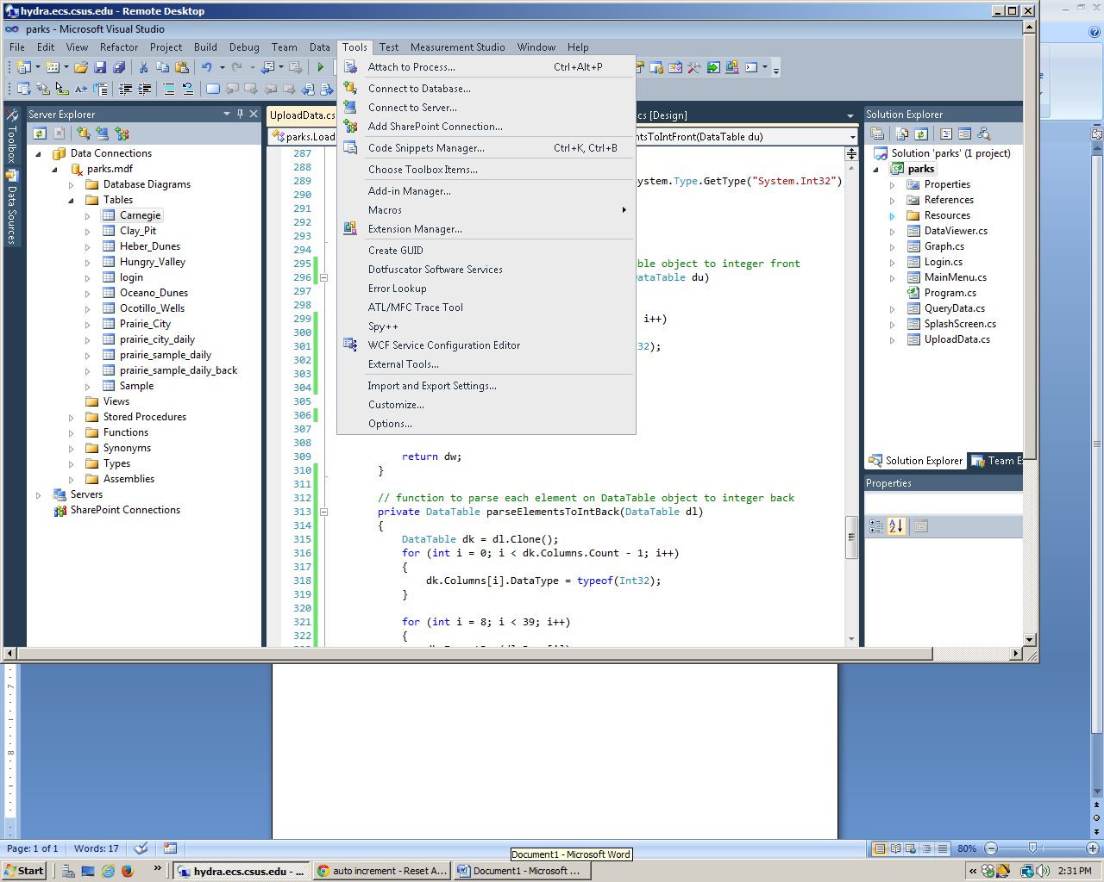
- Then from server explorer select connect database
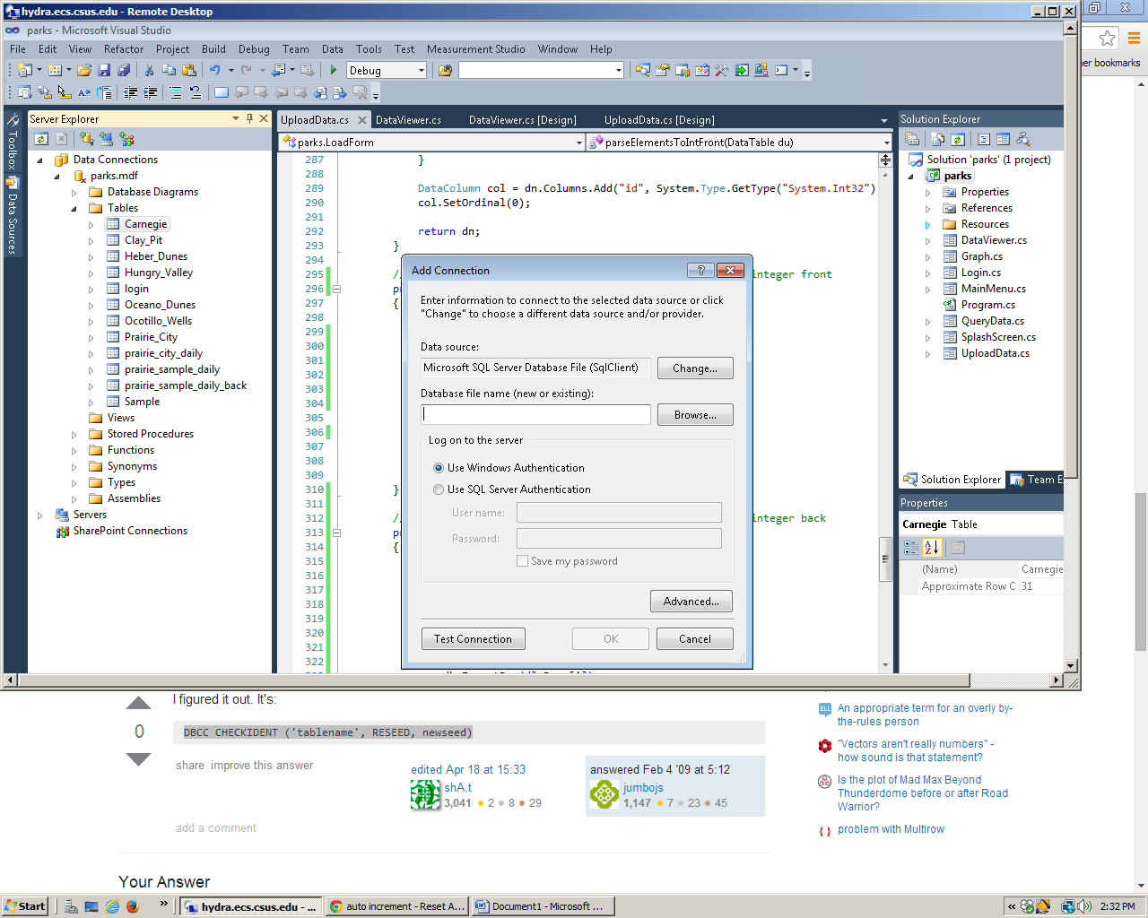
From dialog select the indicated option on the screen shot and select the parks.mdf file

I had to make adjustment to the excel file to work like the ratio colums in back I changes all those ratios to int number 2 and janback and jun back I had to set all zeros on the 12 and 13 columns respectively they were fucking things up

I should have the rest of this done by tomorrow morning

